**EXPERIMENT-2**

**DESIGN OF LOGO USING GIMP**

**Step – 1:** First and foremost, sketch a logo on a piece of paper using pencil or pen.

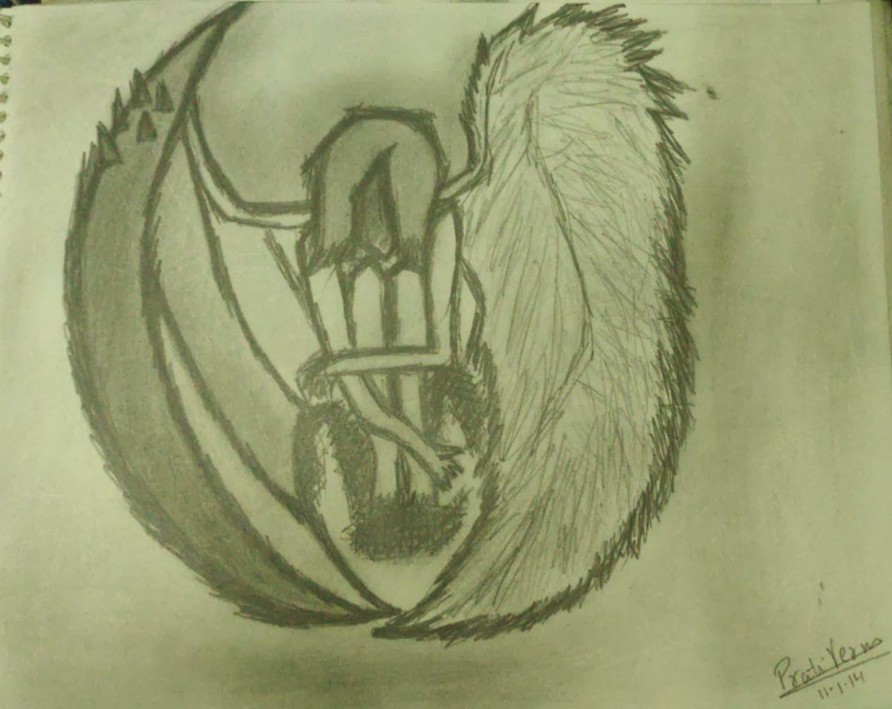

**Step – 2: Open GIMP application** on your computer. Click on File -> Open as layer and open the respective image in the form of layer.

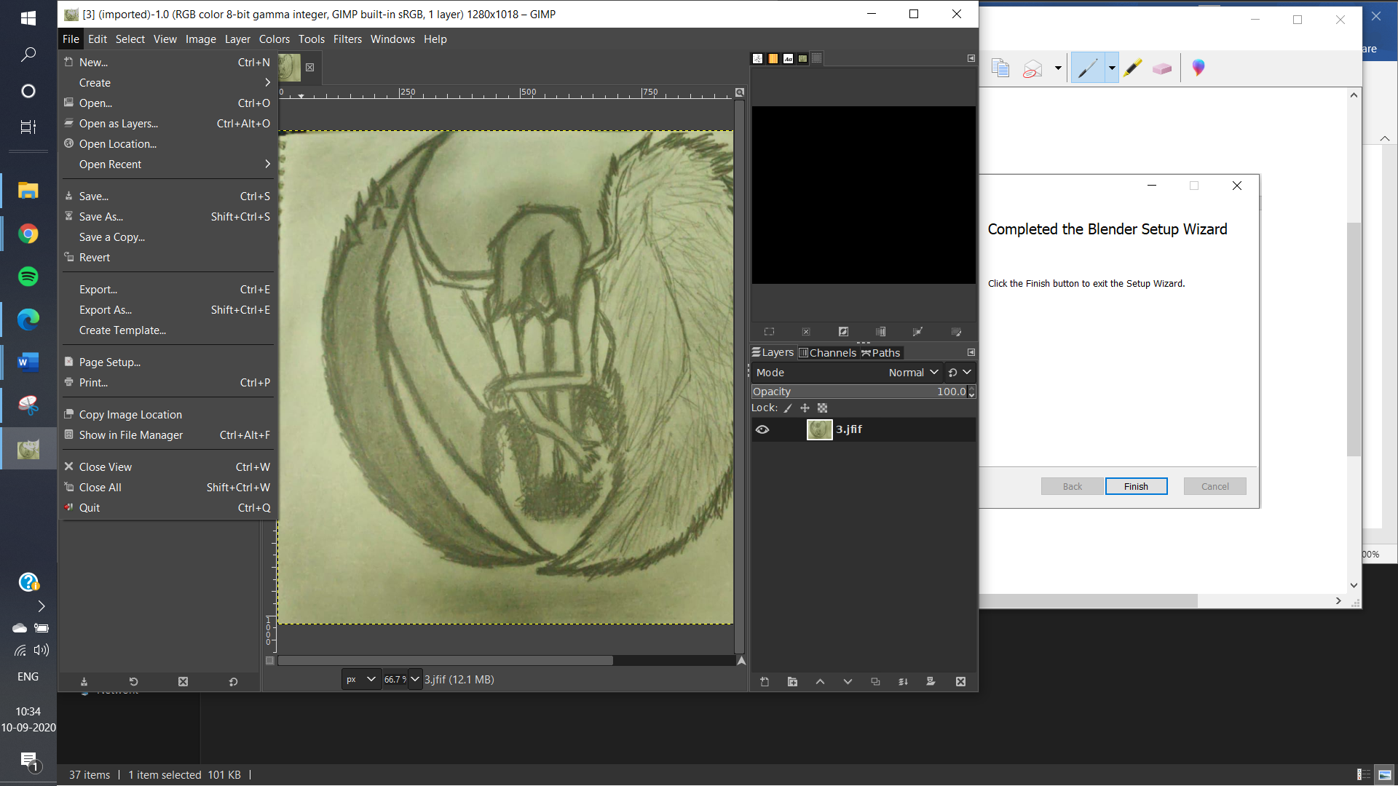

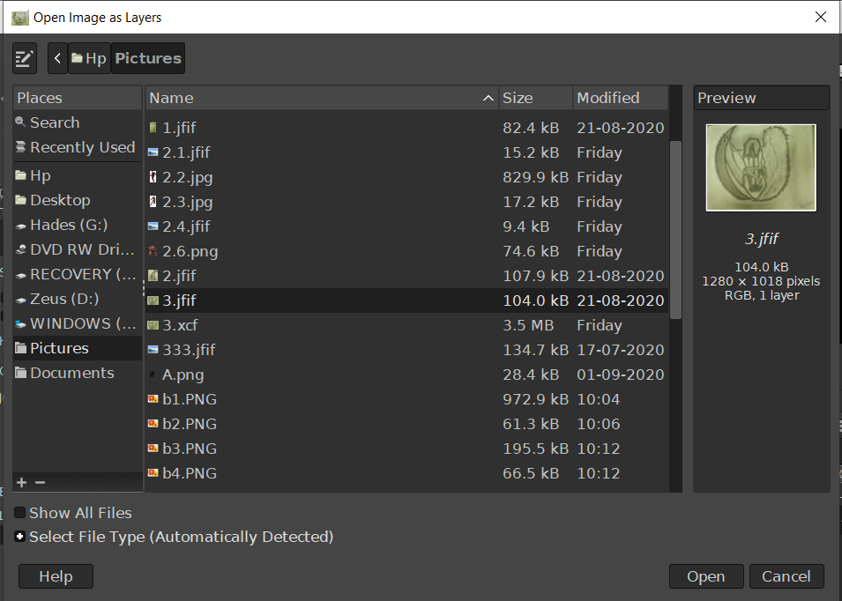

**Step – 3:** Use free select tool in order to the select the boundaries.

**Step – 4:** Connect the first and last point of the boundary and cut the image using CTRL+X. Paste this image on the new layer with background as white colour.

**Step – 5:** Make the changes accordingly using Paintbrush tool from the toolbar. (Optional)

**Step – 6:** Add the text using the text tool. Select the font and font size accordingly.

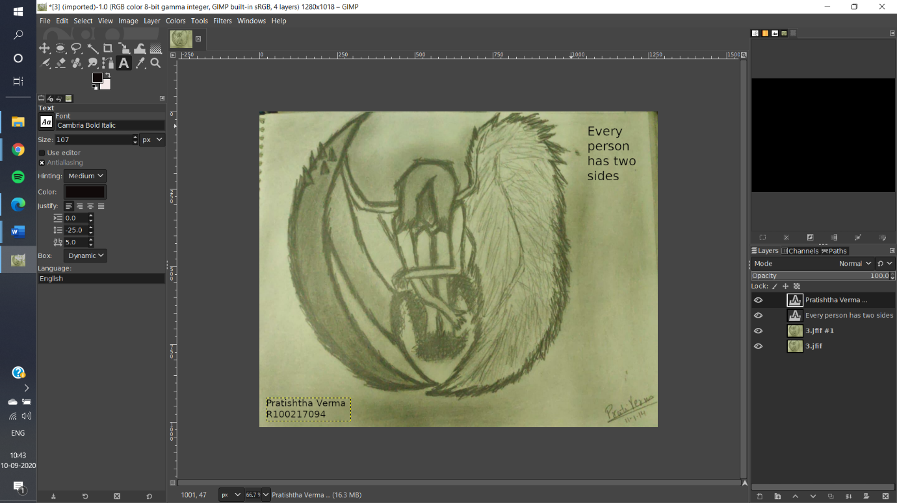

**Step – 7:** Save the image and export the image as .png format.